NAME: S. DHARANI
REG NO: 192472364
COURSE CODE: DSA0401
NUMPY / PANDAS ANALYSIS – QUESTIONS AND ANSWERS
QUESTION 15: FREQUENCY DISTRIBUTION OF POST LIKES
AIM:
To calculate how many posts received each number of likes.
ALGORITHM:
1. Import Pandas.
2. Create a DataFrame of post likes.
3. Use value_counts() to count each like value.
4. Sort and display the frequency distribution.
CODE:
import pandas as pd
df = pd.DataFrame({"Likes": [10, 20, 10, 30, 20, 10, 40]})
frequency = df["Likes"].value_counts().sort_index()
print(frequency)
INPUT:
Likes = [10, 20, 10, 30, 20, 10, 40]
OUTPUT:
Likes
10 3
20 2
30 1
40 1
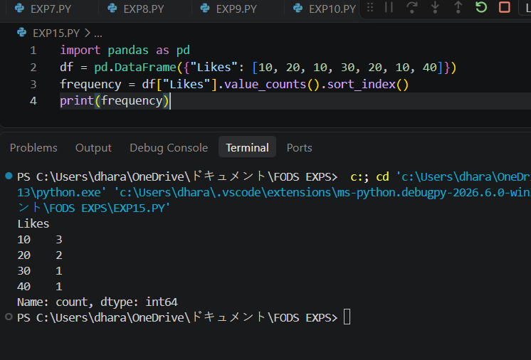
RESULT:
The frequency distribution of post likes was calculated successfully.

